Spesen Skills

**Bankinformationen**

IBAN: CH31 0024 4244 1035 7040 B

Bank: UBS

Adresse: Lorenz Geisser

Alte Strasse 4

9620 Lichtensteig

# Zusammenfassung

|  |  |
| --- | --- |
| Shop | Betrag |
| AliExpress | 3.36 USD 🡪 3.34 CHF |
| LCSC | 25.57 USD 🡪 25.42 CHF |
| Digikey | 60.30 CHF |
| JLC-PCB | 27.02 USD 🡪 26.86 CHF |
| Total: | 115.90 CHF |

# AliExpress

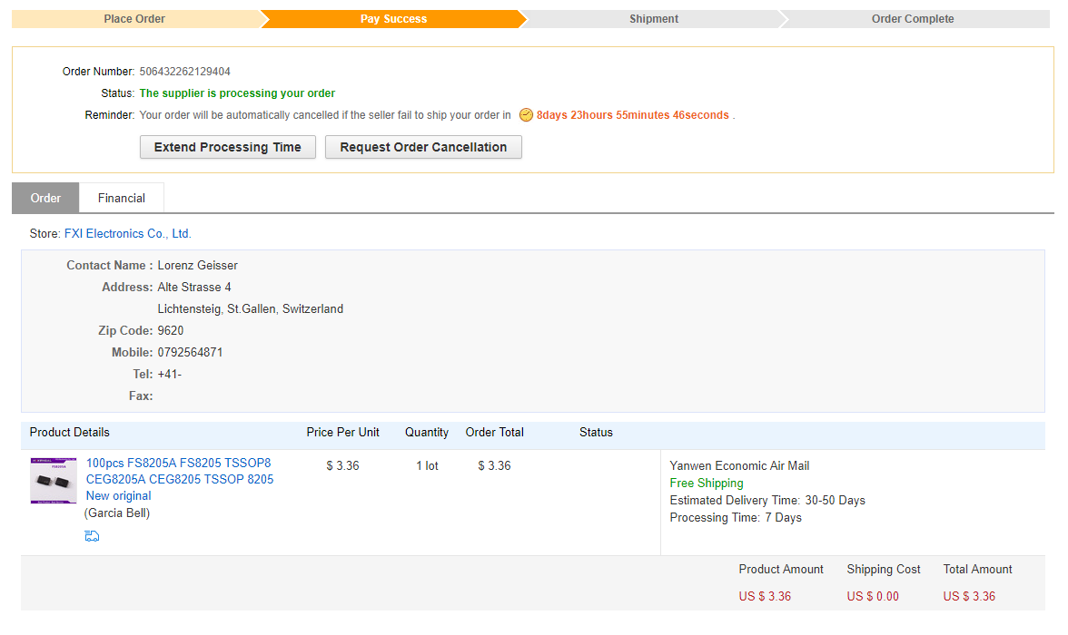

# LCSC

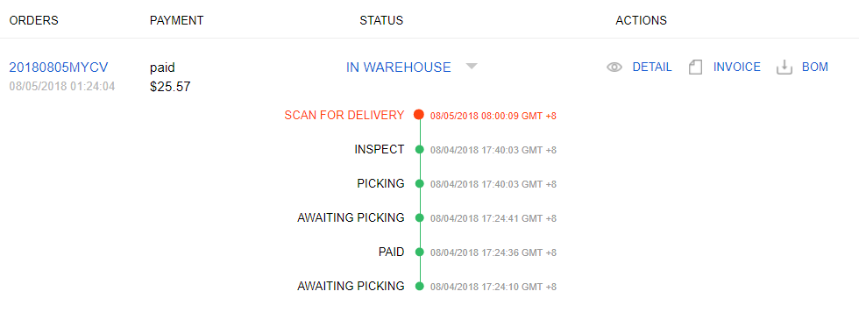

# Digikey

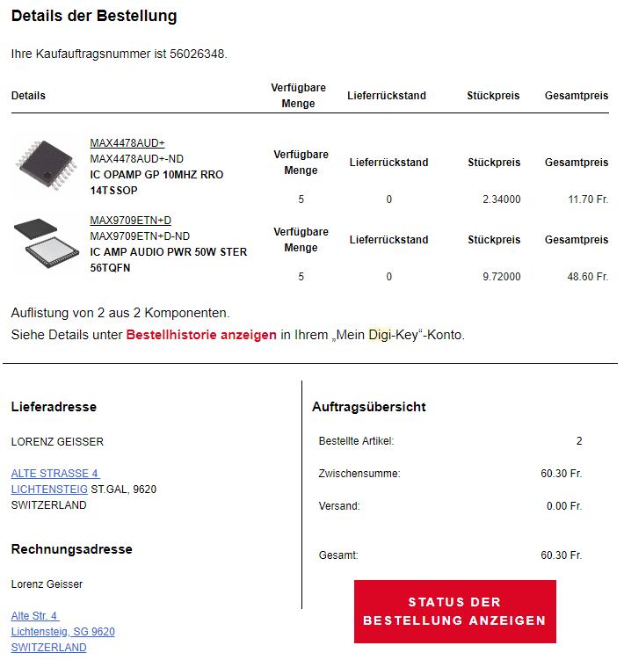

# JLC-PCB

